Micro-organisms



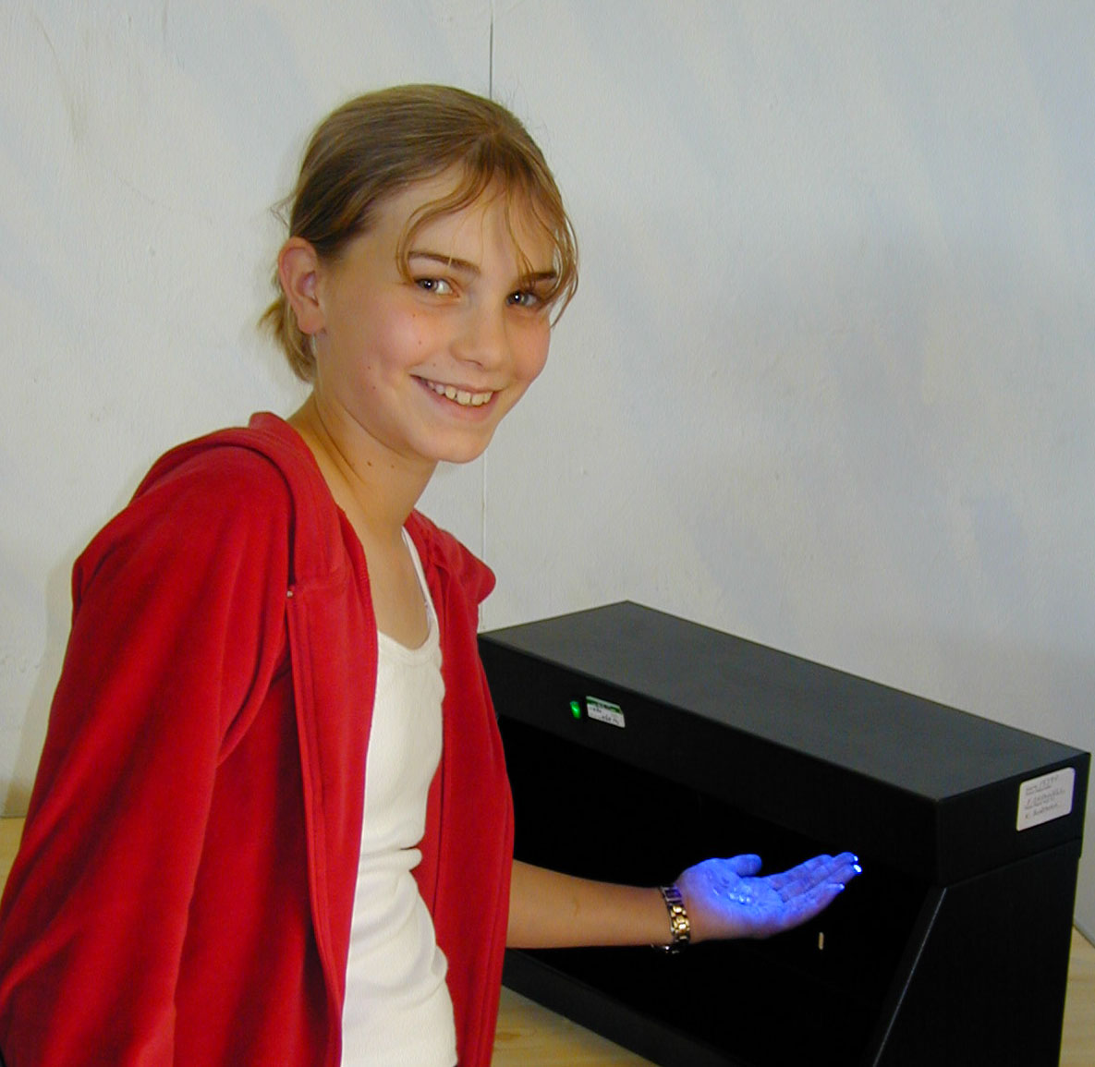

Teachers’ Notes

It should only take about 10 minutes to read these notes. They give some ideas for using the kit.

Additional information is given at the end for interest and further research.

PLEASE READ THIS

Disclaimer
The Teacher Scientist Network (TSN) is pleased to lend its kits to schools, and believes each kit to be suitable for its suggested use. However, we recommend that teachers thoroughly examine and check each kit to make sure it is fit for the purpose intended, making any risk assessment that is appropriate.
The TSN excludes any liability for injury or damage howsoever caused by the use of the kits, is not responsible for the standard of development or safety of any of the products used in the kits, and makes no warranty against errors and omissions in any kit or accompanying material.

Use of Kits

The Teacher Scientist Network is pleased to lend this kit to your school free of charge, and hope that you find it useful.

Please:

- Read the disclaimer and any teachers’ notes.
- Check the kit against the contents list before you take it away.
- Return the kit in a complete and tidy condition ready for the next school
- Don’t keep the kit beyond the date agreed for its return.
- Take care of the equipment.

Although we try to make the kits as robust and child-proof as possible, we might ask you to pay for, or to contribute towards, any breakages or losses other than normal wear and tear.

Thank you for looking after the kit.
contents
page
Disclaimer 3
Contents of kit 5
Introduction 6
Ideas for Activities
1. spreading germs between people 7
2. another hand washing activity 8
3. the hand washing test 8
4. further ideas for activities 9
Spreading germs via objects
Infecting towels
Play spot “The Dirty Dozen” interactive CD-ROM game
Background information
1. germs at a glance 10
2. diseases 11
- Due to fungi 11
- Due to bacteria 12
- Due to viruses 13
3. more detailed information and definitions
· fungi 14
· bacteria 14
· viruses 14
Useful websites 16

Contents of Kit

1 UV light cabinet
2 bottles of “Glitterbug” gel

10 laminated “hospital hand-washing technique” sheets

10 Leaflets: “Follow Frank’s fingertips for clean hands”

6 posters:
- Don’t let germs spread
- Wash your hands
- World of Microbes
- Food poisoners
- Food spoilers
- Food producers

1 book: “Microbes, Bugs and Wonder Drugs”

1 Calamity Kitchen CD

1 set of teachers’ notes

Introduction

This kit provides an exciting and very unusual way to investigate the importance of good hand-hygiene. You can use it to:

· Show how easily germs can be spread
· Demonstrate that a good hand-washing technique must be methodical and involve rubbing the hands together
· Teach the importance of the hands being washed often and well
· Raise the awareness of your class on the importance of good hand hygiene
· Help show the ‘hot spots’ that are often missed when we wash our hands

What are germs?

The word “germs” is a general (non-scientific) term that is used to describe all kinds of micro-organisms (fungi, bacteria and viruses) that can cause disease, illness or infections in people and animals. We would encourage you to use the term ‘micro-organism’.

The Glitterbug gel

The gel in this kit does not contain real germs, but can be used as “pretend germs”. It is invisible under normal light, but glows under Ultra-Violet (UV) light. It is basically a hand cream, with a dye added to make it glow in this way.

Children that are allergic to hand cream should not use the gel.

In the event of ingestion a doctor should be contacted.

In the event of eye contamination with the gel, the eyes should be flushed with water for 15 minutes.
Medical advice should be sought if an irritation persists.
Ideas for activities

- Spreading germs between people

Aims: To demonstrate how easily germs can be passed from one person to another.

· Rub a small (5p size or less) amount of glitterbug gel onto your right hand without your class seeing.

· Go round the class and shake hands with each pupil using either your left or right hand.

· Tell the class that you are going to check their hands for germs.

· Get the pupils to place their hands in the UV light box and split the class into two groups - those that have “germs” on their hands and those that don’t.

· Are there any other similarities between the two groups?

· Finally, tell the class that they don’t really have germs on their hands, but the gel. Tell them that you rubbed a small amount on your hand at the start, and explain that some germs can be spread just as easily as the gel.

- Another handshaking activity:

· The handshaking idea can be expanded – line the children up and rub gel on the hand of the first in line.

· Get the first child to shake hands with the second child in line, and the second with the third, and so on all the way down the line.

· Check the hands of all the children in the light box to see how far down the line the gel was passed just by shaking hands.

- The hand-washing test

Aims: To demonstrate that good hand washing must be methodical and involve rubbing the hands together, to raise the children’s awareness of the importance of good hand hygiene, and to demonstrate the importance of washing the hands often and well.

· Apply a small amount of “Glitterbug” gel to one hand of each pupil. Tell each pupil to rub the gel in evenly over all areas of both hands.

· Check the hands in the UV light box to see the “pretend germs”.

· Now ask the class to wash their hands, as they normally would do after going to the toilet or before eating a meal.

· Dry the hands thoroughly and place them under the UV light box again.

· If the hands have been washed thoroughly, none of the fluorescent gel will be visible.

· Usually, the common areas missed during hand washing will be illuminated: fingernails, thumbs, between the fingers, and the backs of the hands. Also look out for the results of people wearing stony rings, wristwatches, plasters or bandages.

· Re-apply the glitterbug gel as before.

· Instruct the class to wash their hands according to the “hospital hand-washing technique”.

· Dry the hands again and check them under the UV light box.

· Note the (hopefully visible!) reduction in the amount of gel left on the hands.

· Stress the importance of good hand-washing.

- Further ideas for activities

- Model spreading germs via objects such as pens, telephones etc. by applying glitterbug gel before handling them. Let another person handle the pen and then look at their hands under uv light. Have germs been spread?

- Towels can be infected with germs after incomplete hand washing. Examine paper towels after hand drying. Which towels would be most hygienic – paper or linen?

- Play “The Dirty Dozen” interactive game

Background information
- Germs at a glance
Micro-organisms can be good, bad or both. Some examples are given below:

Bacteria
• Plant disease – tomato blight
• Food decay – rotten bread & fruit
• Human disease – tetanus, syphilis, typhoid
• Source of antibiotics – streptomycin
• Fixing of nitrogen from the air (used in making protein)
• Food poisoning – toxin production
• Food production – vinegar, yoghurt, cheese
• Decomposition – natural ecosystems & sewage works

Viruses
• Human disease – influenza, polio, measles, HIV
• Plant disease – leaf curl diseases
• Variegation in flowers & foliage

Fungi
• Food production – mushrooms, quorn ™
• Yeast fermentation – beer, wine, marmite
• Food decay – Botrytis spp.
• Human disease – athletes foot
• Plant disease – rusts, mildew, ergot
• Antibiotic production – Penicillium
• Food spoilage / toxicity – Fusarium spp.
• Food decomposition – natural ecosystems, composting

2. Diseases, illnesses and infections due to microorganisms

- Due to fungi:
Although many mushrooms and toadstools are toxic and should never be eaten, they aren’t considered to be “germs” because they aren’t micro-organisms. Examples of fungi that we might call germs include those given in Table 1.

Illness, disease or infection | Fungus | Treatment
“Ringworm”, “Athletes foot”, other diseases of the skin and nails | Tinea | Many medications are available but treatment usually results in control rather than cure.
Coccidioidomycosis, “Valley fever”. An acute lung infection that may cause a chronic pulmonary condition or spread further in the body. Prevalent in the SW United States. | Coccidioides | In 95% of cases the patients recover spontaneously
Large array of illnesses including allergic conditions and infections of the sinuses and lungs. | Aspergillus | Treatment depends on the type and severity of the disease
Table 1 – Some fungal diseases, illnesses and infections

- Due to bacteria:
Bacteria cause illness either by attacking the tissues directly, or by producing toxins that damage the tissues. Antibodies provide natural defence against harmful bacteria. Antibiotic medicines can provide defence against some bacteria, but recently new strains of more virulent bacterial pathogens have emerged, some of which are resistant to antibiotics. Examples of bacteria that we might call germs include those given in Table 2.

Illness, disease or infection | Bacterium | Treatment
Bronchitis – inflammation of the lining of the trachea (windpipe), bronchial tubes, and bronchioles resulting from a respiratory tract infection | Haemophilus influenzae and Streptococcus pneumoniae | Dietary and other lifestyle changes can be very effective, but medication is also available.
Meningitis – infection of the fluid in the spinal cord and the fluid around the brain. Can be quite severe and may result in brain damage, hearing loss, or learning disability | Streptococcus pneumoniae and Neisseria meningitidis (H. influenza) | Antibiotics only work if the disease is detected early. Infant vaccines have almost eliminated H. influenzae.
Some strains of E. Coli produce toxins that cause food poisoning. Symptoms vary from mild diarrhoea to a more severe illness with fever, nausea, vomiting or haemorrhaging. Can be fatal. | E.coli | Usually resolved in 1 to 3 days. Re-hydration fluids may be needed. Very severe cases may require kidney dialysis or blood transfusions.
Tuberculosis – usually results in a lung infection but other organs can be affected. Symptoms include coughing, chest pain, shortness of breath, fever and fatigue. | Mycobacterium tuberculosis | Antibiotics are usually effective treatments for Tuberculosis.
Tetanus – a serious infectious disease of the nervous system, in which a bacterial toxin causes severe muscle spasm. About 60% of all cases are fatal, but immunisation, is highly effective against infection. | Clostridium tetani, | Bacilli can be eliminated by surgery or with antibiotics. Neutralising the toxin with antitoxin reduces muscle spasm.
Table 2 – Some bacterial diseases, illnesses and infections
- Due to viruses:

It can be difficult to treat viral infections because antibiotics are ineffective. In many cases only the symptoms can be treated to give relief from the condition, but the actual condition can only be left to resolve itself. Examples of viruses that we might call germs include those given in Table 3.

Illness, disease or infection | Virus | Treatment
Meningitis – generally less severe than the bacterial form. Symptoms may include fever, headache, stiff neck and fatigue. A Rash and intestinal symptoms may also occur. | Various, including common intestinal viruses and mumps. | Symptoms can be treated but there is no specific treatment for the condition. It usually resolves itself.
Influenza – acute respiratory tract infection. It causes sore throat and coughing, and often headache, muscle ache, weakness and fever. | Can result from any of several strains of “myxoviruses”, | Bed rest and analgesics to control the fever is usually recommended. Vaccines decrease the risk of infection.
AIDS (Acquired Immunodeficiency Syndrome) - fatal disorder of the immune system causing vulnerability to malignancies and infections that eventually cause death. | HIV- The human immunodeficiency virus | No vaccine or cure exists. Many drugs including AZT (azidothymidine), and ddI (dideoxyinosine), are now used to delay the onset of AIDS.
Chicken pox – contagious disease usually infecting young children. The major symptom is an eruption of red, itchy, raised blisters over the skin. Each blister lasts for about four days. May cause raised temperature. | The “varicella-zoster” virus. This is the same virus that causes shingles. | Patients are usually isolated initially and confined to bed to stop the disease spreading. Scratching should be prevented to stop blisters from ulcerating and scarring.
Table 3 – Some viral diseases, illnesses and infections

3. More detailed information and definitions

1. Fungi

- The basic structure in most types of fungus is a fine strand called a hypha. Hyphae tangle together into a network called the mycelium, which forms the “body” of a fungus.
- The growth of the hyphae within the mycelium can be very rapid.
- The cell walls of fungi are composed of chitin or other non-cellulose compounds.
- Many fungi can be seen with the naked eye, but others are classed as micro-organisms because they can only be seen with a magnifying glass or microscope.

2. Bacteria

- Bacteria are simple, single-celled micro-organisms that lack a membrane-bound nucleus.
- They are very small (about 1mm wide and 5mm long) – several hundred could fit side by side across the width of one human hair.
- They exist in different forms, usually being spiral (spirillum), round (coccus) or rod-shaped (bacillus).
- Many bacteria (normally the bacillus and spirillum forms) have flagella on their outer surface, and are able to swim about by moving these in a whip-like manner.
- Some types have pili - rod-like protrusions that serve as tethers.

3. Viruses

Viruses are about 1000 times smaller than bacteria ... so minute that they are only visible with the use of an electron microscope.
The structure of a virus is very simple, consisting of a core of genetic material (DNA or RNA) surrounded by a protein coat.
Some viruses have an additional outer coat called an envelope, which is made of fats and sugary proteins.
Viruses are infectious agents, but can only multiply and carry on their metabolic processes in the host cell of another organism, such as a plant, animal or bacterium.
Viral infections do not respond to treatment with antibiotics.
Useful websites

www.wiredforhealth.co.uk
Recommended by Gill Malcolm from Little Plumstead school, Norwich

Web sites with further information on fungi:
www.doctorfungus.org/

Web sites with further information on bacteria:
www.ucmp.berkeley.edu/bacteria/bacterialh.html
www.oxylit.com/foodpoisoning.html

Web sites with further information on viruses:
www.howstuffworks.lycos.com/virus-human1.htm
www.ucmp.berkeley.edu/alllife/virus.html

More web sites to help with teaching about the importance of hygiene
www.microbe.org/experiment
This site has lots of experiments including one about hand washing.

www.foodlink.org.uk
www.foodfitness.org.uk
These are two government websites that have lots of information in a very accessible format.

www.cdc.gov/ncidod/op/cleaning.htm
This site is a good source of further information for teachers or older pupils. It covers hand-washing, cleaning, food, immunisation, antibiotics, pets and wild animals. There are links to more sites and additional material for downloading and for printing off.

